Made a water shader. What it does it will modify the y of the position based on a sin and cos of the x and z coordinate and total time. This creates a wave affect and also the texture animates in the direction of the waves move. This is done in the vertex shader and the fragment shader gives it an alpha of 0.7.

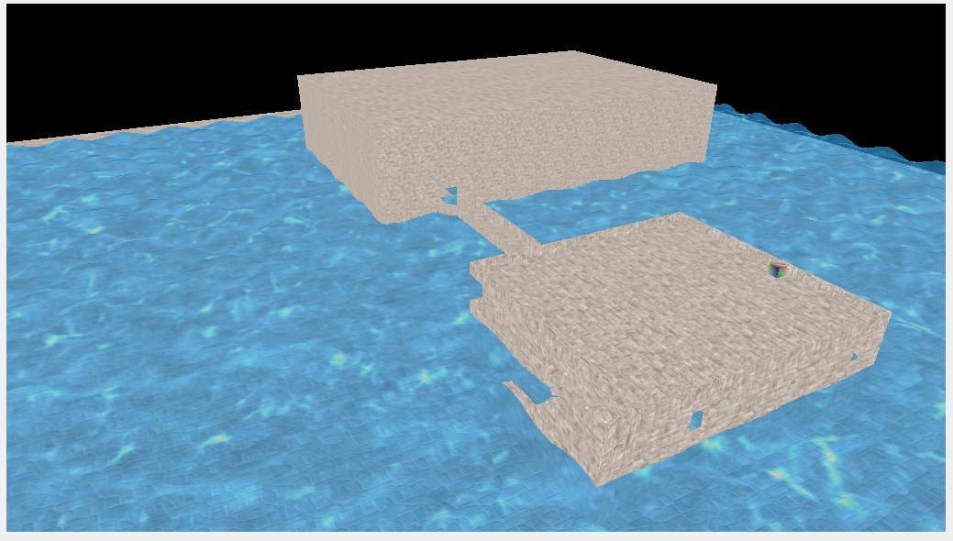

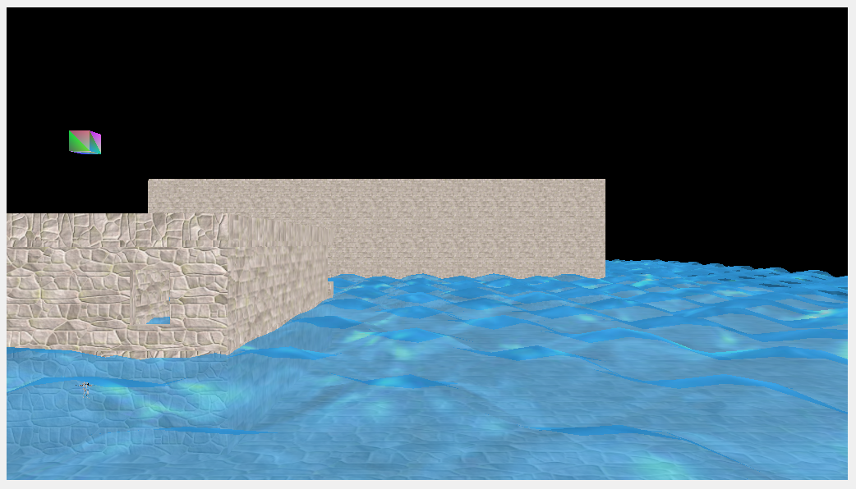

//Vertex Shader

#version 430

in layout(location = 0) vec4 vertexPositionModel;

in layout(location = 1) vec2 vertexUV;

out vec2 UV;

uniform mat4 modelToProjectionMatrix;

uniform float time;

void main()

{

vec4 pos = vertexPositionModel;

pos.y = sin( pos.x + time ) * cos( pos.z + time ) * .5f;

gl_Position = modelToProjectionMatrix * pos;

vec2 tex = vertexUV;

tex.x -= time * 0.05f;

tex.y -= time * 0.05f;

UV = tex;

}

//Fragment Shader

#version 430

in vec2 UV;

out vec4 daColor;

uniform sampler2D myTexture;

void main()

{

daColor = texture( myTexture, UV );

daColor.a = 0.7;

}